**Spring Boot**

* It’s not a framework but way to create any kind of spring application with minimal or zero configurations.
* It has been developed on top of existing framework.
* It reduces lots of development time and increases productivity.
* It provides configuration and embedded HTTP servers like tomcat ,jetty etc to develop and test our application very easily.
* We have to avoid using jsp because spring boot using embedded servlet container so lot of issue will come. So at the place of jsp we can use freemarker or groovy etc.
* It provides command line interface(CLI) tool to develop and test spring boot applications from command prompt very easily and quickly.
* Provides lots of plugins to develop and test spring boot applications very easily using build tools like Maven and Gradle. So we write very less configuration in pom.xml.
* **Limitation of Spring Boot**

1. Best for new spring application not for converting existing or legacy project to spring boot application.

* **Ways to Create Spring Boot Applications**

1. By using spring boot CLI.
2. By using <http://start.spring.io>
3. By using STS(spring tool suite) IDE similar to eclipse.

**Spring Integration**

* It supports event driven architecture that is based on three core components.
* **Messages** : It’s a object that is sent from one component to another.
* **Channels** : Used to send message .they can be synchronous or asynchronous.
* **Adapters** : Used to take output from one channels to the input to another one.

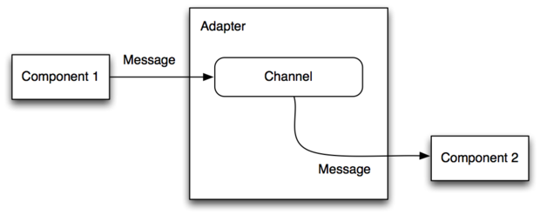

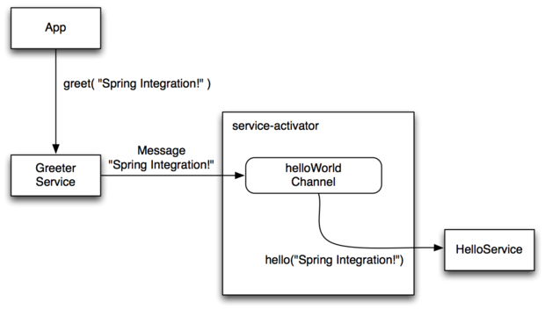

**Spring Batch**

* Used to process any operation once in a day then spring batch comes into the picture.
* It provides some functions to process large no of data in batch jobs. EX: logging, transaction management, reading or writing files, reading or writing data into database etc.

